**7.6 Using Trigonometry to Solve for Sides HW**

*Find the value of each expression to the nearest ten-thousandth.*

1) sin 12° 2) tan 53° 3) cos 78°

4) sin 45° 5) tan 16° 6) cos 29°

*Solve for the variable.*

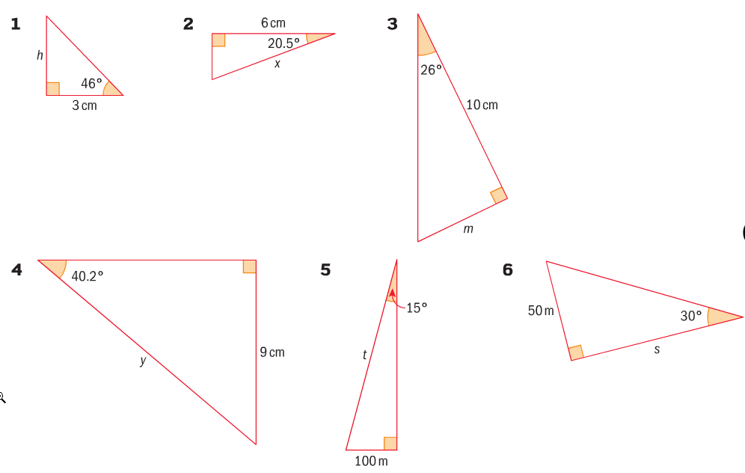



**IB Style Questions – Up to 4 points of Extra HW Credit!**

